International Farrier Competition
Jósvafő, Hungary
18th-19th August 2012

Organizer: Hungarian Farrier Association
National Park Aggtelek - Hucul Stud Farm (Carpathian breed)
Referees: Denis Leveillard (France)
David Gulley (UK)
Venue: H-3758 Jósvafő, Táncsics u. 1. (www.huculmenes.hu)
The aim of the event is - beside a competition among traditional farriers - to preserve and forward their knowledge for future generations.
At the competition farriers from different countries present the technological specificities of their national farrier schools in order to improve each other’s professional development. The well renowned and respected team of international referees guarantees the unambiguous judgment of the highly demanding tasks to be performed.
Simultaneously to the farrier competition the International “Hucul Path” (horse competition and show) will take place. Visitors will also get an inside into the beauties of the National Park, visit the unique system of dripstone caves and join a colorful equestrian festival.
Hungarian and international competitors are invited to attend.

Registration
The first twenty applicants can be registered.
Application fee EUR 50,-
Valuable prizes to win
Shuttle service between Budapest Airport and the venue will be organised for competitors and company. Low-cost accommodation on the spot will be provided. Please indicate your requests in advance.
Registration at Mr Ormándi, Zsolt
info@mape.hu
Tasks for the competition

- The first task is to prepare in 2x60 minutes 4 horseshoes.
- Two of these are detailed below and see also pictures
a) special hind-shoe 25x10x280 and
b) ¾ fullered deep seated bar shoe 25x10x405.
B) Two others will be surprise shoes - indicated on the spot only.

2) As a second task one side of a horse (one fore and one hindlimb) have to be shoed in 90 minutes with a shoe having bent calkins (bar 20x8cm, calkin 8mm – see picture).
Coal-forges are provided by the organisers. Assistance can be used at the anvil and horse only but not for maintaining the fire.

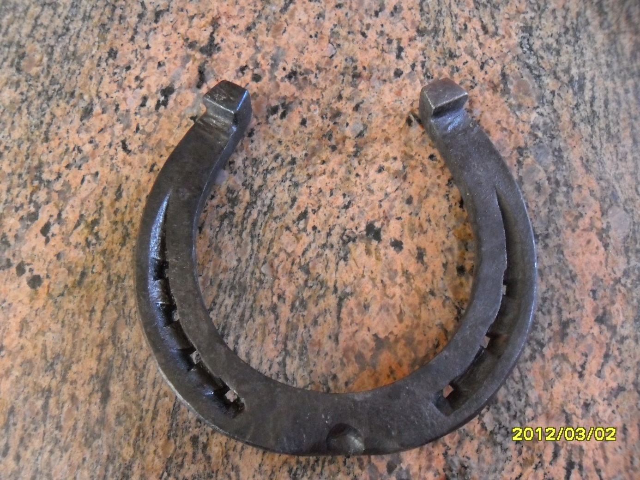

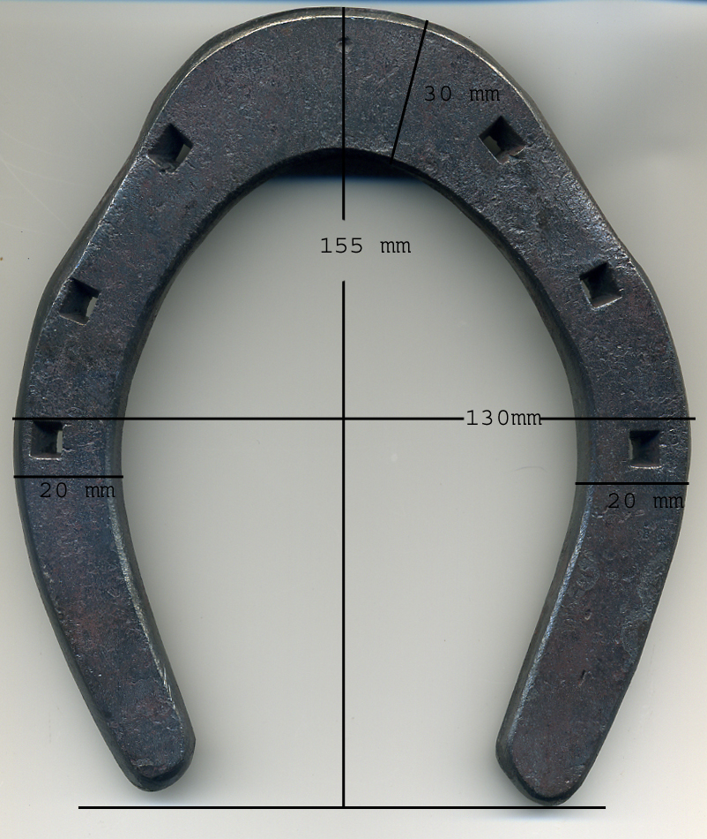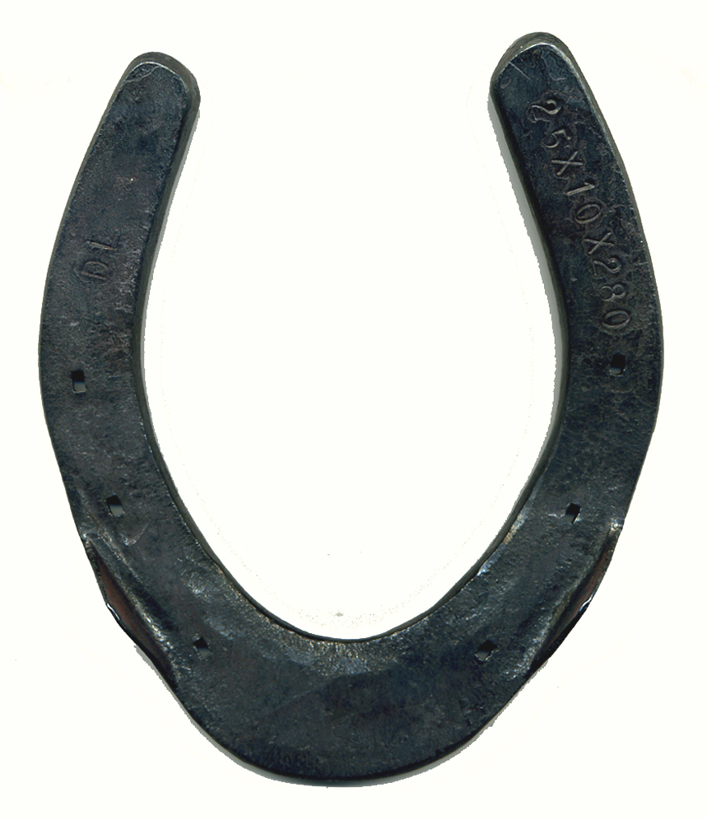
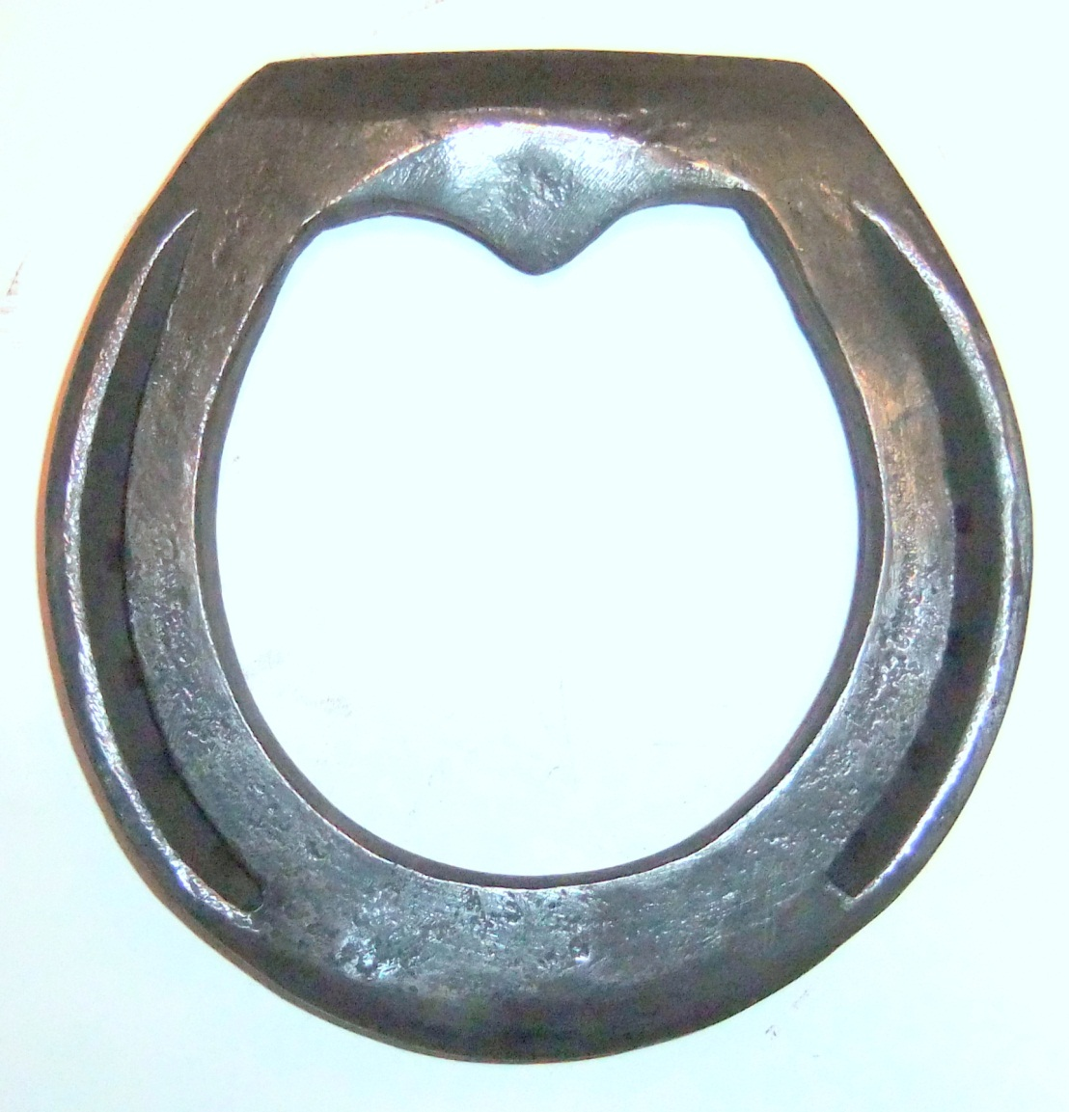
155mm
160mm

